**Federation University**

**Victoria, Australia**

**Content Analysis on**

**IT Service Management and Professional Culture**

**Submitted by:**

Ranjeet Karki: 30339903

**Course:**

ITECH 7400, IT Service Management and Professional Culture.

**Course Lecture/Tutor:**

Dr Salafi Yusef

**Contents**

1: Introduction to IT service management

2: ITIL Framework for IT Governance

2.1: Service Strategy

2.2: Service Design

2.3: Service Transition

2.4: Service Operation

2.5: Continual Service Improvement

3. Balance in service operation

4.Financial Management for IT Services

4.1 Accounting

4.2 Budgeting

4.3 Charging

5.Capacity Management

5.1 Business Capacity Management

5.2 Service Capacity Management

5.3 Component Capacity Management

6.Information Security Management

6.1 Availability

6.2 Confidentiality

6.3 Integrity

6.4 Authenticity

7. Measurement of Business success

7.1 critical success factor

7.2 Metrics

7.3 Key Performance Indicators

7.4 Baseline

8. Deming Cycle

9. References

**Introduction of IT service management**

IT Service Management (ITSM) is considered a sub-discipline of the Service Science that can be defined as “a set of processes that cooperate to ensure the quality of live IT services, according to the levels of service agreed to by the customer”. ITSM focuses on defining, managing and delivering IT services to support business goals and customer needs, usually in IT operations. There are several ITSM-related standards and process models have emerged such as ISO/IEC 20000, CMMI-SVC (Capability Maturity Model Integrated for Services) and ITIL (Information Technology Infrastructure Library) .One of the most popular approach used by ITSM is ITIL framework which helps business to realize that business can change, growth and transform. It provides the basis for quality ITSM through documented and well-established processes that cover all the service lifecycle. In recent years, a growing number of organizations are implementing ITIL in an attempt to improve their ITSM processes and provide significant benefits. Thus, implementing an ITSM reference model has become one of the main priorities for IT companies to assure their continuity and maximize the return of investment and business opportunities.

The following figure illustrates how the service lifecycle is initiated from a change in requirements at the business level.

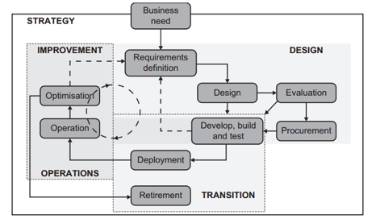

Fig1: The ITIL Service Management Model(from week1 slide 20)

IT service management (ITSM) is a general term that describes a strategic approach to design, deliver, manage and improve the way businesses use information technology (IT).

**ITIL Framework for IT Governance**

The ITIL framework can be a key part of the foundations for excellent IT governance. IT is a service business, and the adoption of ITIL service management practices is an effective way to address IT governance. For example: Service strategy ensures that IT investments not only address issues that are important to the business, but also that they are sound investments that take proper account of costs, benefits and risk.

IT Governance is an integral part of the enterprise governance in defining leadership, organizational structures and processes to achieve the planned objectives and to increase the sustainability of enterprises, with the focus to improve the management and control the information technology (IT Governance Institute, 2004; National Computing Centre, 2005). IT Governance covers five key areas for IT management and control, such as IT and Business Strategy Alignment, Value Delivery, Risk Management, Resource Management and Performance Measurement (IT Governance Institute, 2004).

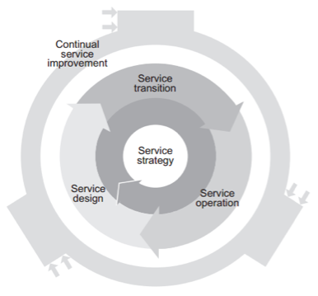

Fig2: ITIL service operation(from week 3,slide 3)

**Service Strategy**: The business team will make a plan or vision to differentiate themselves from their competitors. They will do a cost analysis and risk analysis for their service portfolio for effective decision making.

**Service Design**: Service design should support the perspective that are already develop in service strategy. The main goal of the management team is to return on investment.

**Service Transition**: The company move from paper to actual building and validation the product

**Service Operation:** The main aim is to make sure that the service is running effectively and efficiently.

**Continual Service Improvement**: Although there are no changes in the organization there is always room for improvement and development. The company learn from the past mistake and improve them.

**Balance in Service Operation**

In every organization the one constant is change. In operation all functions, processes and related activities have been design to deliver specific level services. These services deliver defined and agreed levels of utility and warranty and doing so while delivering an overall value to the business. The catch is this has to be done in an ever-changing environment where requirements, deliverables and perceived value changes over time. Sometimes this change can be evolutionary or can take place at a very fast pace.

This struggle can be broken down into four general imbalances so that an IT organization can identify that they are experiencing an imbalance by leaning more towards one extreme or the other. At a high level it can provide the service provider with the opportunity to develop some guidelines on how to resolve these conflicts and move towards a best practice approach in resolving these discrepancies.

1.Internal IT view vs. External business view

2.Stability vs. Responsiveness

3.Service quality vs. cost

4.Reactive vs. proactive

It is crucial that we achieve a balance between these views. Services must be design and delivered around customer’s needs and requirements. They must have the ability to create the desired business outcomes for the users and deliver necessary value to the customer. At the same time however it can be possible to compromise those needs and requirements by not planning and properly executing on how those services will be delivered. Conflict arises because constant, agreed levels of service need to be delivered in a continually evolving technical and organizational environment. Getting the balance wrong can mean services are too expensive, unable to meet business requirements, or unable to respond in good time.

**Financial Management for IT Services**

The main goal of the Financial Management in IT Services is to wisely use appropriate level of funding for design, develop and deliver the services that helps to meet the strategy of the organization. It has three processes

**Accounting**:

It is the systematic way of presenting the financial information. It tracks the finances so that the it helps the organization for better decision making. It usually involves accounting systems, including ledgers, charts of accounts, journals etc. and should be overseen by someone trained in accountancy.

**Budgeting**:

This process plans income and expenditure of money for an organization. Planning is done periodically (usually once a year). Planning is important because it decreases risk of overspending in the future. Process of predicting and controlling the income and expenditure of money within the organization. Consists of a periodic negotiation cycle to set (usually annual) budgets, monthly monitoring of current budgets.

**Charging**:

This is the process required to bill customers for the services supplied to them. This requires sound IT accounting practices and systems. Process of predicting and controlling the income and expenditure of money within the organization. Consists of a periodic negotiation cycle to set (usually annual) budgets, monthly monitoring of current budgets. It makes a difference whether the organization is an internal service provider, or if it serves external customer as its main business. In the case where an IT organization is an internal service provider (according to ITIL, these are Type I and Type II organizations), it is not necessary to bill for services. Sometimes such IT organizations only allocate costs. If an IT organization sells its services to external customers (Type III organization) they will, certainly, issue bills for their services and generate income which funds that organization.

**Capacity management**

Capacity management is the practice of right-sizing IT resources to meet current and future needs. It’s also one of five areas of ITIL Service Delivery. The Capacity Manager is responsible for ensuring that services and infrastructure are able to deliver the agreed capacity and performance targets in a cost effective and timely manner.

**Business Capacity Management**: Business Capacity Management translates business needs into requirements. Business Capacity Management should predict changing requirements for capacity demand and manage such demand on a tactical level. This means that Capacity Management is involved in planning processes as well as financial and service level management processes is usually the top business priority for organizations and constructing a BP capability is one of the main challenges for senior executives (Gartner GROUP 2010 Gartner GROUP. 2010. “Leading in Times of Transition: The 2010 CIO Agenda.” EXP Premier Report No January 2010, Gartner, Stamford, CT. Business process modelling (PM) is the act of capturing and graphically describing organizational processes.

**Service Capacity Management**: The focus of this sub-process is the management of the performance of the live, operational IT Services used by the Customers. It is responsible for ensuring that the performance of all services, as detailed in the targets in the SLAs and SLRs, is monitored and measured and that the collected data is recorded, analyzed and reported. As necessary, the action is taken to ensure that the performance of the services meets the business requirements.

**Component Capacity Management**: When service levels fall below target, component capacity management is the sub-process responsible for identifying the necessary changes to the technical infrastructure to maintain service levels. The utilization of components should be continually monitored against their capacity. When a threshold is reached that could cause service levels to be missed.

**Information Security Management**

Information security (InfoSec) describes activities that relate to the protection of information and information infrastructure assets against the risks of loss, misuse, disclosure or damage. ISM is a part of ITIL Service Design. Information security management is important in IT service management. The main objectives of information security are as follows:

**Availability**: Information is available and usable whenever required and the systems that provide it can appropriately resist attacks and recover from or prevent failures.

**Confidentiality**: Information is observed by or disclosed to only those who have a right to know.

**Integrity**: Information is complete, accurate, and protected against unauthorized modification

**Authenticity and non-repudiation**: Information exchange between enterprises can be trusted.

The goal of an ISMS is to minimize risk and ensure business continuity by pro-actively limiting the impact of a security breach. ITIL suggests that ISMS should address what it calls “The Four P’s”: people, process, products and technology, and partners and suppliers.

ITIL does not provide a detailed explanation of all aspects of Information Security Management, as there are dedicated and more detailed standards available. Rather, ITIL highlights the most important activities and assists in identifying interfaces with other Service Management processes. The main activities of Information Security Management are:

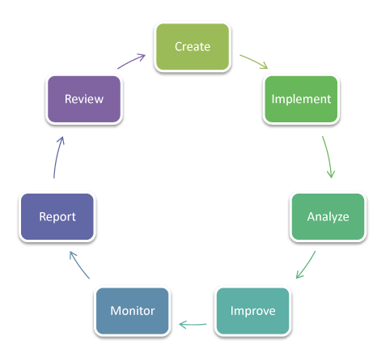

**Measurement of Business Success**

Goals, baseline, KPIs, and CSFs are interrelated in performance management and improvement framework.

**Critical Success Factor**

Critical success factors were first introduced by D. Ronald Daniel in a 1961 Harvard Business Review (HBR) article. Daniel highlighted the types of information needed to support top management activities. CSFs identify areas that are critical to the success of the enterprise. CSFs identify areas that are critical to the success of the enterprise. They tend to be high level and few in number. CSI might have senior management involvement or commitment as a CSF.

**Metrics**

Metrics are the number with in the KPI that helps to track the progress and performance of the organization. However, metrics are not a KPI, they are needed to determine if our KPIs is satisfied or not. There are seven types of metrics. They are goal metrics, Qualitative metrics, Quantitative metrics, Actionable metrics, informational metrics and vanity metrics.

**Key Performance Indicators:** Key performance indicators represent a particular value or characteristic that is measured to assess whether an organization's goals are being achieved. They reflect the critical success factors, stakeholder needs, and the expectations of the organization. For KPIs and their measures to be effective, the organization's goals need to be specific, measurable, agreed, realistic and time-based. KPIs can use both financial and non-financial metrics.

KPIs are used in conjunction with CSFs and must have a target that is to be achieved. The target for a KPI can be expressed as a percentage, a simple ratio, an index, a composite average or in a statistical context. Whatever is chosen as a KPI and a target must be actually measurable though. At the outset, keeping the number of KPIs for a single CSF in the range of 3-5 is recommended.

**Baseline**

A baseline is a benchmark that is used as a foundation for measuring or comparing current and past values. For example, a company wanting to measure the success of one of its product lines can use the number of units sold during the first year as a baseline from which to evaluate subsequent sales growth. The main purpose of the baseline is to provide a reference point against which to demonstrate future improvement.

**Deming Cycle**

The Deming Cycle is a continuous quality improvement model consisting out of a logical sequence of four repetitive steps for continuous improvement and learning. By applying the deeming cycle the company comes closer to its vision step by step. In 1987 Moen and Nolan [16] presented an overall strategy for process improvement with a modified version of Deming’s cycle of 1986. The planning step of the improvement cycle required prediction and associated theory. The third step compared the observed data to the prediction as a basis for learning

**Plan**: Choose a process and set objectives to deliver results in accordance with the expected output.

**Do**: Implement the plan and begin collecting data on the results. Collect data for charting and analysis in the following "CHECK" and "ACT" steps. A

**Check**: Analyze the results using statistical methods. Study the actual data and compare against the expected results.

**Act**: Decide what changes to make in order to improve the process.

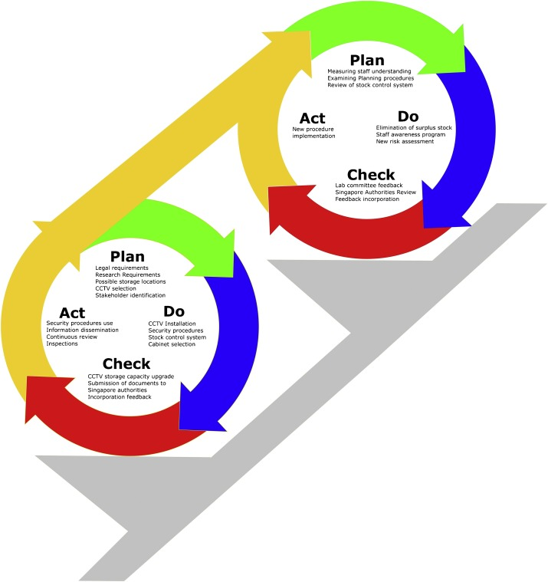

Figure 1. Deming Cycle as applied to explosive precursor safety in Singapore.

The PDCA(Plan, Do ,Check ,Act) was popularized by Dr. W. Edwards Deming. He was an American engineer, statistician and business consultant. It is also called father of modern quality control(QC). Deming theory is based on TQM (Total Quality Management ) and ISO 9001 quality standards. TQM is divided into four sequential categories: Plan ,Do, Check and Act.

**References**

National Computing Centre (2005) A Best Practice guide for decision makers in IT THE UK S LEADING PROVIDER OF EXPERT SERVICES FOR IT PROFESSIONALS. Available at: https://www.isaca.org/Certification/CGEIT-Certified-inthe-Governance-of-Enterprise-IT/Prepare-for-theExam/Study-Materials/Documents/Developing-aSuccessful-Governance-Strategy.pdf

IT Governance Institute (2004) IT Governance Global Status Report, IT Governance Institute. doi: ISBN 1-893209- 32-6.

The Statutes of the Republic of Singapore: Arms and Explosives Act (Chapter 13). Revised edition 2003. Retrieved from https://sso.agc.gov.sg/Act/AEA1913, accessed on 7/12/2018.

Met4ITIL: A process management and simulation-based method for implementing ITIL

Gartner Group. (2010). Leading in times of transition: The 2010 CIO Agenda. EXP Premier Report No January2010.

Elena Orta.(2017,11 August).Met4ITIL: A process management and simulation-based method for implementing ITIL.Retrieved from *https://www-sciencedirect-com.ezproxy.federation.edu.au/science/article/pii/S0920548917303057*

Financial Management for IT Services.Retrieved from *https://www.greycampus.com/opencampus/itil-foundation/financial-management-for-it-services*

CSF's, KPI's, Metrics, Outcomes and Benefits.Retrieved from *http://www.itsmsolutions.com/newsletters/DITYvol6iss5.htm#go1*

Moen, R., & Norman, C. (2006). Evolution of the PDCA cycle.

|  |  |
| --- | --- |
| Parmenter, D. (2015). Key performance indicators: developing, implementing, and using winning KPIs. John Wiley & Sons. |  |
|  |  |